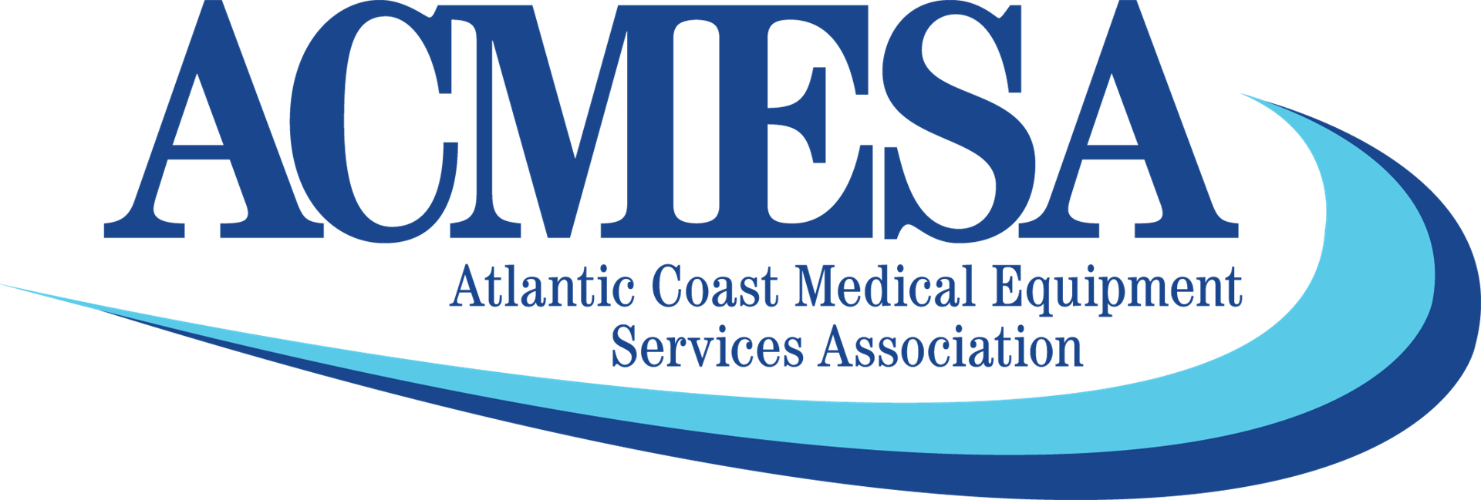

ACMESA Virtual ConferencE
February 2-4th, 2021

February 2nd, 2021
10:00-11:45 pm  1:30-2:30pm | Federal and State Legislative Update  Roundtable: COVID-19 Impact | John Gallagher and Laura Williard  Mark Higley, Kelsey Burke, Jay Bracken, John Gallagher, Craig Douglas
2:30-4:00pm  4:00-5:30  February 3rd, 2021  10:00-11:00am  1:30-2:30am  2:30-4:00p  4-5:00pm | Exhibitor Hall Hours  Virtual Happy Hour!  Creating opportunities for meaningful Engagements with your regional CMS office  Round 2021 Competitive Bidding  Exhibit Hall Hours  MEDICARE Update with Your Ombudsman | Virtual Exhibit Hall  Zoom Platform  CMS Regional Office Rep.  Mark Higley, Craig Douglas, Ronda Buhrmester  Virtual Exhibit Hall  Judie Roan
February 4th, 2021  11am  2pm  3pm  4pm  TBD  February 5th, 2021  11:30 am | West Virginia Medicaid Session  Virginia Medicaid Session  North Carolina BCBS Session  North Carolina Session  North Carolina MCOs  NC MCO – Healthy Blue

On-Demand CEU courses available until February 19th
Respiratory Track
Mask Impact on PAP Effectiveness: How Facial Scanning Can Help | Megan Tiffany- Philips Respironics
Maximizing Profitability with Your Complex Respiratory Program | Ronda Buhrmester, & Dave Lyman VGM
Oxygen Patients on the Move: OCDs, POCs, and Device Best Practices | Nick Macmillan, Ventec Life Systems
Clinical Application of EtCO2 monitoring for Non-invasive Ventilation Therapy | Timothy Quinn, Masimo
COPD/Chronic Respiratory Failure Overlap/Wrap-around Syndrome | Ron Hosp, Breathe, LLC
Transitioning into Pulmonary Service Provider: How to build a payor program | Dan Easley, Encore Healthcare, LLC
Rehab Track
Complex Rehab Technology Update | Don Clayback, NCART
From the Inside Out: Exploring the Clinical Applications of Wheelchair Cushion Material | Angie Kiger, Sunrise Medical
Documenting the Medical Need to Operate Power Seat Functions through the Joystick, | Julie Piriano, Pride Mobility
Wheelchair Repairs - The Good, The Bad and The Ugly | Dan Fedor- VGM, & & Jim Stephenson, Permobil
Tilting the Odds: Manual Tilt to Improve Rehabilitation Outcomes | Debbie Pucci, KI Mobility
Billing/Reimbursement Track
Patient collection strategies that work, and the results that prove it | Jennifer Leon, Brightree
Intake and Documentation: The Key to Positive Cash Flow | Sarah Hannah, ECS North
Start Gaining Traction with Commercial Payers, | Sarah Hannah, ECS North
Audit Update: What can we expect? | Wayne van Halem, van Halem Group
COVID-19 Policy Changes – What is Temporary and What is Here to Stay | Craig Douglas and Ronda Buhrmester, VGM
HR/General
Self IT Audit: Adapting for Today’s Cybersecurity | Nick Dideriksen of VGM Forbin
Leadership and Data – A Hand in Hand Approach | Miriam Lieber, Lieber Consulting LLC
Embracing Patient Engagement | Cheryl Henninger, Gerould's Professional Pharmacy Inc
Managing your Business’s Financial Health During Tough Times | Jim Nygren, VGM
Human Capital: The new landscape of HR | VGM's HR team

